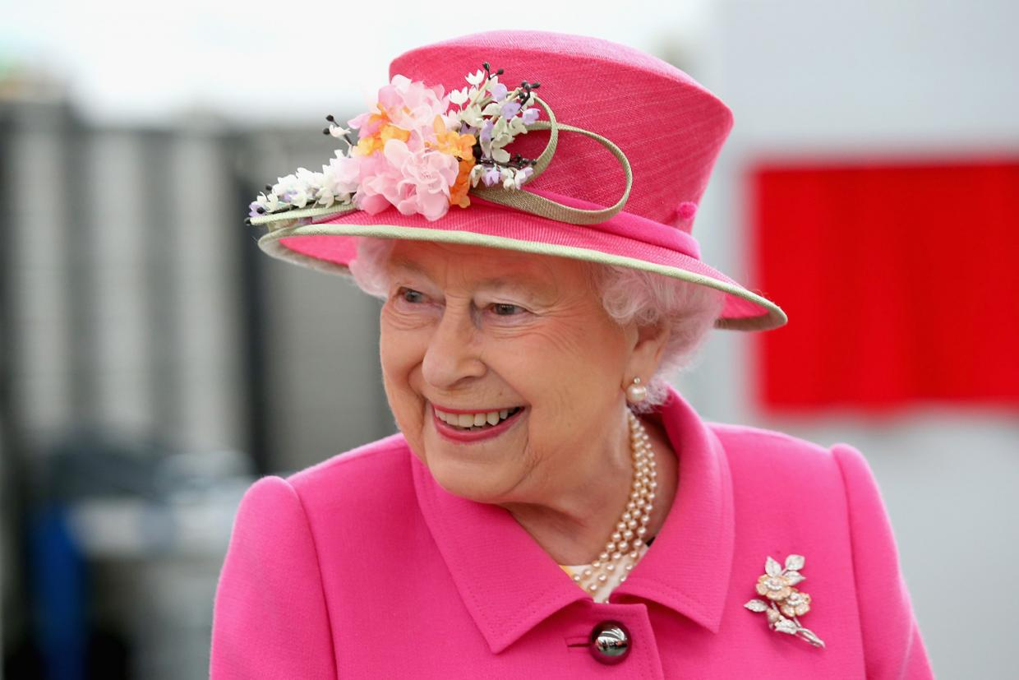

Surprising Facts About Queen Elizabeth II
- Her real birthday is April 21, but it is celebrated officially in June.
- She speaks fluent French and often uses the language for audiences and state visits.
- She is the longest reigning monarch ever in Britain. There have been 13 U.S. Presidents during her reign.
- Her Majesty has a nickname “The Queen of Hats” as she’s worn about 5,000 different hats over the past 50 years.
- The Queen and her husband have four children: Prince Charles and Princess Anne, who were born before Elizabeth became queen, and Prince Andrew and Prince Edward.
- The Queen was the first British monarch to celebrate her diamond wedding anniversary.
- Her Majesty has 30 godchildren.
- The Queen joined Facebook in November 2010, with a page called the British Monarchy, which features royal news, photos, videos and speeches.
- Elizabeth learned to drive in 1945, when she joined the women's branch of the British army. Both she and Winston Churchill's daughter were members of the group.
- The Queen is the only living person in Britain who is allowed to drive without a license or a license plate on her car, and since all British passports are issued in her name, she doesn't need a passport to travel around the world either.
- The Queen is a keen photographer and enjoys taking pictures of her family.
- The Queen adores dogs, her favourite are corgis. Elizabeth has owned more than 30 corgis during her reign, starting with Susan, who was a present for her 18th birthday in 1944.
- She takes a keen interest in horses and racing. Elizabeth has about 25 horses in training each season.
- In the past 60 years, the Queen has undertaken 261 official overseas visits, including 96 state visits, to 116 different countries.

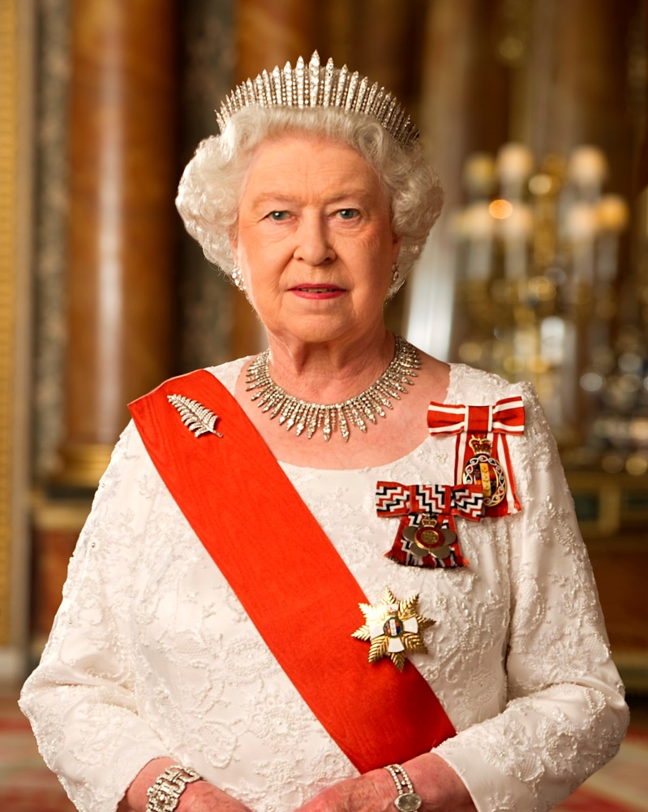

Elizabeth II (Elizabeth Alexandra Mary Windsor; born 21 April 1926^{[a]}) has been Queen of the United Kingdom, Canada, Australia, and New Zealand since 6 February 1952. She is Head of the Commonwealth and Queen of 12 countries that have become independent since her accession.
Elizabeth was born in London as the eldest child of the Duke and Duchess of York, later King George VI and Queen Elizabeth, and she was educated privately at home. Her father acceded to the throne on the abdication of his brother Edward VIII in 1936, from which time she was the heir presumptive. She began to undertake public duties during the Second World War, serving in the Auxiliary Territorial Service. In 1947, she married Philip, Duke of Edinburgh, a former prince of Greece and Denmark, with whom she has four children: Charles, Prince of Wales; Anne, Princess Royal; Prince Andrew, Duke of York; and Prince Edward, Earl of Wessex.
Elizabeth's many historic visits and meetings include a state visit to the Republic of Ireland and visits to or from five popes. She has seen major constitutional changes, such as devolution in the United Kingdom, Canadian patriation, and the decolonisation of Africa. She has reigned through various wars and conflicts involving many of her realms. She is the world's oldest reigning monarch as well as Britain's longest-lived. In 2015, she surpassed the reign of her great-great-grandmother, Queen Victoria, to become the longest-reigning British monarch and the longest-reigning queen regnant and female head of state in world history. In October 2016, she became the longest currently reigning monarch and head of state following the death of King Bhumibol Adulyadej of Thailand.

Use reference materials and the Internet to answer the questions below. Read the question and circle the correct answer.
1) What foreign language does Queen Elizabeth II speak fluently?
a. Spanish
b. French
c. Italian
2) How many children does she have?
a. 2
b. 3
c. 4
3) The Queen is also known as
- The Queen of Hats
- The Queen of Corgis
- The Queen of People
4) Which is her favourite breed of dogs?
- Labrador
- Corgi
- spaniel
5)Who was prime minister when Queen Elizabeth II was crowned in 1952?
a. Winston Churchill
b. Tony Blair
c. Harold Macmillan
6) Queen Elizabeth II lives at which property during August and September?
a. Windsor Castle
b. Balmoral Castle
c. Buckingham Palace

7) What year did the Queen send her first email?
a. 1999
b. 1992
c. 1976
8) The Queen was the first British monarch to visit what country?
a. Yemen
b. China
c. Laos
9) Queen Elizabeth II celebrates her public birthday in the UK in what month?
a. June
b. April
c. January
10) What is the name of Queen Elizabeth II’s eldest son?
a. Philip
b. Andrew
c. Charles
